PUT THE TITLE OF PAPER HERE, IN CAPITAL LETTER (UPPERCASE)
WITHOUT LINE SEPARATION

ABSTRACT

Abstract with no more than 300 words should be supplied to reflect the content of the paper. A concise and factual abstract is required. Background. Provide context or background for the study and state the study’s primary objective or hypothesis in 1–2 sentences. Also, please explain the previous research/program what other people do or what you have done before. Author include hypothesis (if any) which explained the tentative of result. Methods. Describe the basic procedures used during the study, including selection of study subjects, observational, analytical methods, and define the primary outcomes. Results and discussion. Summarize the main findings, including specific effect sizes and their statistical significance, if possible. Include (if relevant) the number of participants in each group, the primary outcome for each group, and any significant adverse events or side effects. Also, please explain relation between your theory and your result in your article. Conclusion. In 1–2 sentences, state the principal conclusions, emphasizing new and important aspects of the study or observations in aspect of your research. An abstract is often presented separately from the article, so it must be able to stand-alone. For this reason, References should be avoided. Also, non-standard or uncommon abbreviations should be avoided, but if essential they must be defined at their first mention in the abstract itself.

Keywords: Alphabetically sorted; Capitalized first word; Maximum 5 keywords; Sentence case; Separated by semicolon (;)

1. INTRODUCTION

Provide an adequate background, context of the problems based on the literature review. State the objectives of the work and emphasize the originality (state of the art). The first paragraph of a section or subsection should not be indented; subsequent paragraphs should be indented like the following paragraph. In the end of this section, please also briefly state the structure of paper, starting from Title up to References. Please follow this citation style: Citation should be in following style: (Julio, 2018), (Ahmed & Saleh, 2017), (Gretz et al., 2017), (Fowler et al., 2018a; Fowler et al., 2018b), (Joe et al., 2014; Dexler, 2016; Adams, 2018).
There is no theoretical background section in this manuscript. But, you must input your theoretical background on Introduction section. Theoretical background contains previous theories as the basis of research and the temporary hypothesis. The theory can be in the form of scientific articles, articles in journals, textbooks, or other sources of scientific writing. This theory will be used to provide state of the art of your manuscript from research problems that have been proposed. After the theories are mentioned and discussed, you need to form a problem that show why this manuscript is important, existing gaps, previous research and you as an Author must write the purpose of the manuscript.
Introduction text - Introduction text - Introduction text - Introduction text - Introduction text - Introduction text - Introduction text - Introduction text - Introduction text - Introduction text. Introduction text - Introduction text - Introduction text - Introduction text - Introduction text.

2. METHODS

Provide sufficient detail methods to allow the work to be reproduced. Methods already published should be indicated by a reference: only relevant modifications should be described. Methods are the means used by the author to answer the existing research problem. The method must clear with the location and time of the research, the population and sample of the research, the research variables and the research data. Describe the basic procedures used during the study, including selection of study subjects and observational and analytical methods
Methodology text - methodology text - methodology text -methodology text - methodology text - methodology text -methodology text - methodology text - methodology text - Methodology text -methodology text - methodology text - methodology text - methodology text. Methodology text -methodology text - methodology text - methodology text - Methodology text -methodology text - methodology text - methodology text - methodology text.

3. RESULTS AND DISCUSSIONS
Result and discussion contains results obtained by the author during the research. The results of the research submitted in advance as a whole, which continues by doing the process of discussion. Result and discussion of your manuscript also interconnected with your theory that used. The discussion is presented systematically from general, then leads to the specific. Presentation of the research can be done with the help of tables, drawings/graphs, maps/plans, and schemes. Minimum of your explanation on this chapter is range 40% to 50% of your manuscript
Results should be clear and concise. Results should be clear and concise Results should be clear and concise. Results should be clear and concise. Discussion must explore the significance of the results of the work. Adequate discussion or comparison of the current results to the previous similar published articles is recommended to shows the positioning of the present research (if available).
The figure number and caption should be typed below the illustration in 10 pt and centered. If the figures get on other sources, write the name of source below the figures, left justified. The figures on your manuscript must send separately from your manuscript with high resolution. Below is an example which the authors may find useful.

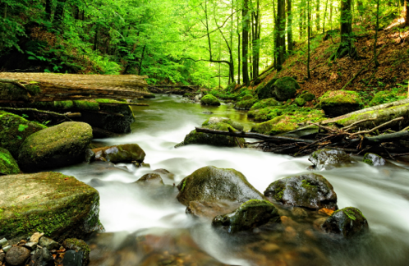
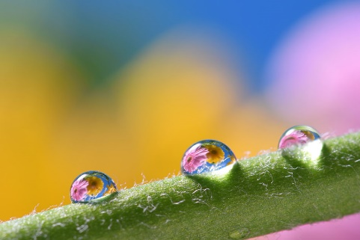
b
a

Figure. 1 (a) first picture; (b) second picture
(Source: An Example of Source. Year of Source)

Result text - Result text - Result text - Result text - in Figure 1. Result text -Result text - Result text - Result text - Result text - Result text -Result text - Result text - Result text - Result text - Result text -Result text - Result text - Result text - Result text - Result text -Result text - Result text - Result text - Result text (Table 1).
Table 1. Number of receptors in each container
An example of a column heading | Column A (t) | Column B (t)
And an entry | 1 | 2
And another entry | 3 | 4
And another entry | 5 | 6
(Source: An Example of Source. Year of Source)

Result text -Result text - Result text - Result text - Result text - in Figure 1. Result text -Result text - Result text - Result text - Result text - Result text -Result text - Result text - Result text - Result text - Result text -Result text - Result text - Result text - Result text - Result text -Result text - Result text - Result text - Result text.
Formulae should be numbered consecutively throughout the manuscript as Equation 1. In cases where the derivation of formulae has been abbreviated, it is of great help to the reviewers if the full derivation can be presented on a separate sheet (not to be published). Formulae should be centred and numbered.

(1)

Discussion text - Discussion text - Discussion text - Discussion text - Discussion text - Discussion text - Discussion text - Discussion text - Discussion text - Discussion text - Discussion text - Discussion text - Discussion text - Discussion text - Discussion text - Discussion text - Discussion text - Discussion text - Discussion text - Discussion text - Discussion text - Discussion text - Discussion text - Discussion text - Discussion text - Discussion text.

4. CONCLUSION

The main conclusion of the study may be presented in a short conclusions section, which may stand-alone. It should not repeat the results, instead provide significant findings and contribution of the study. To close this section, state some important limitations of research, followed by potential future research regarding the issue. This conclusion is maximum 2 paragraph
Conclusion text - Conclusion text - Conclusion text - Conclusion text - Conclusion text - Conclusion text - Conclusion text - Conclusion text - Conclusion text - Conclusion text - Conclusion text - Conclusion text - Conclusion text - Conclusion text - Conclusion text - Conclusion text - Conclusion text - Conclusion text - Conclusion text - Conclusion text - Conclusion text - Conclusion text - Conclusion text - Conclusion text - Conclusion text - Conclusion text - Conclusion text.

5. ACKNOWLEDGEMENTS (IF ANY)
Acknowledgements on this manuscript at the end of the manuscript before the references and do not, therefor, include them on the title page or otherwise. List on this tab those individuals or company that provided help during your research. The example of providing your research, e.g., providing language help, writing assistance, data collect, proof reading the article, etc.

6. REFERENCES
Meanwhile, references should be in APA style constructed with Mendeley. For more information, please check https://open.mendeley.com/use-citation-style/apa

For example:
Brennan, M. A., & Israel, G. D. (2008). The power of community. Community Development, 39(1), 82-97.
McKibbin, B. (2007). Deep economy: The wealth of communities and the durable future. New York: Times Books/Henry Hold and Co.
Pigg, K. E., & Bradshaw, T. K., (2003). Catalytic community development: A theory of practice for changing rural society. In D. L. Brown & L. E. Swanson (Eds.), Challenges for rural America in the twenty-first century (pp. 385-396). University Park, PA: Pennsylvania State University Press.
U.S. Census Bureau. (2018). State and Country QuickFacts. Washington, D.C.: United States Bureau of the Census. Retrieved November 7, 2017, from http://quickfacts.census.gov/qfd/

